**For Installing Appium**

**Steps**

1. **Install Java 9 and provide the path and JAVA_HOME in Environment Variable.**

**Eg :** 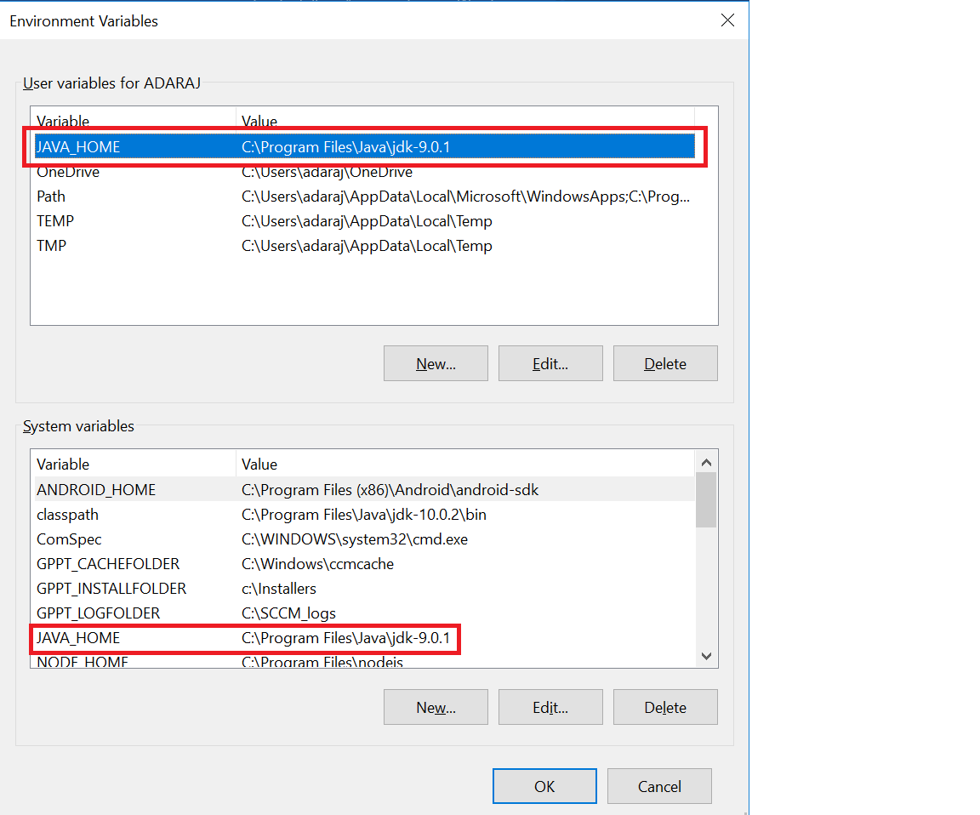

**Provide JDK and JRE location under the path**

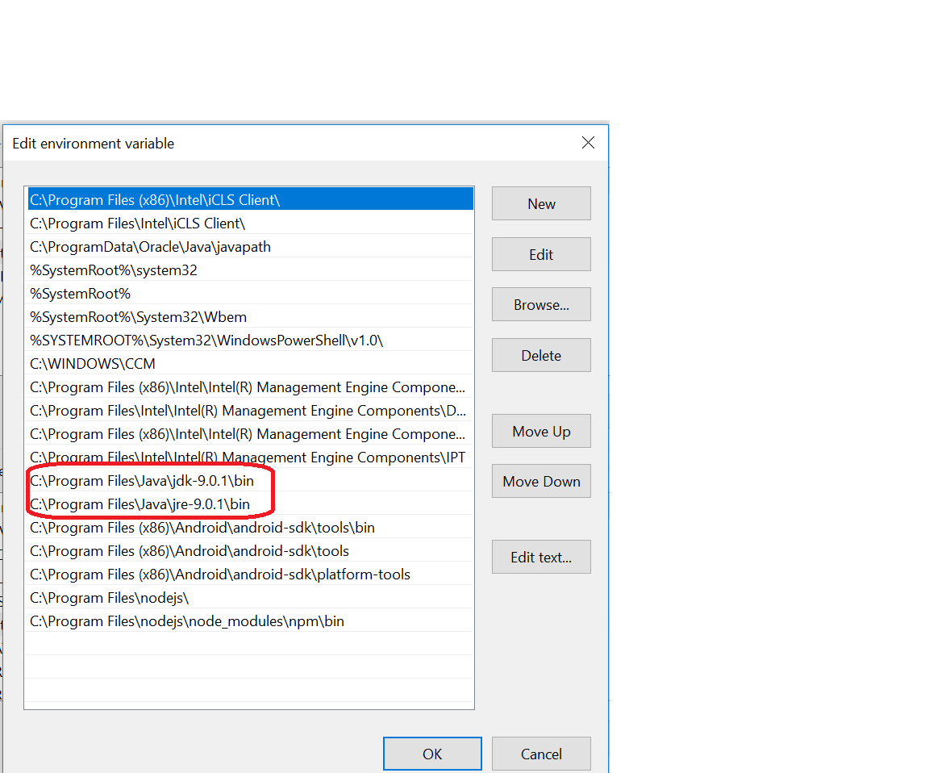

1. **Download SDK from the following link🡪** <https://dl.google.com/android/installer_r24.4.1-windows.exe>
2. **Set ANDROID_HOME environment variable path to the SDK location**

**Eg :**

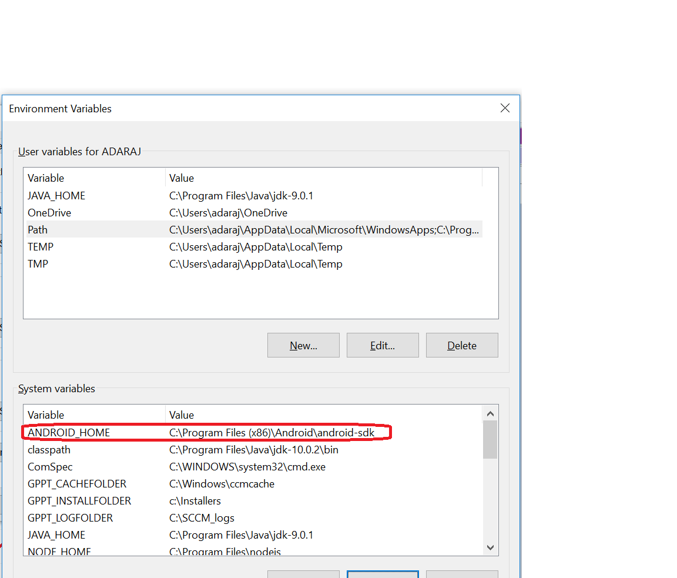

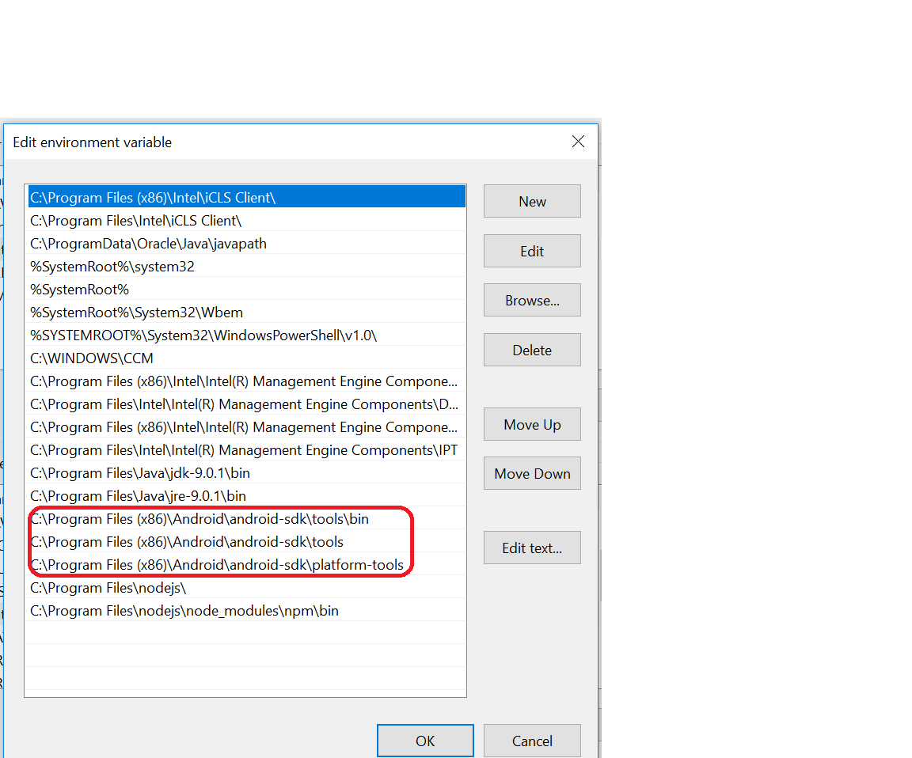

1. **Download Node js from the following link 🡪 https://nodejs.org/en/download/**
2. **Provide the NODE_HOME path in environment variable**

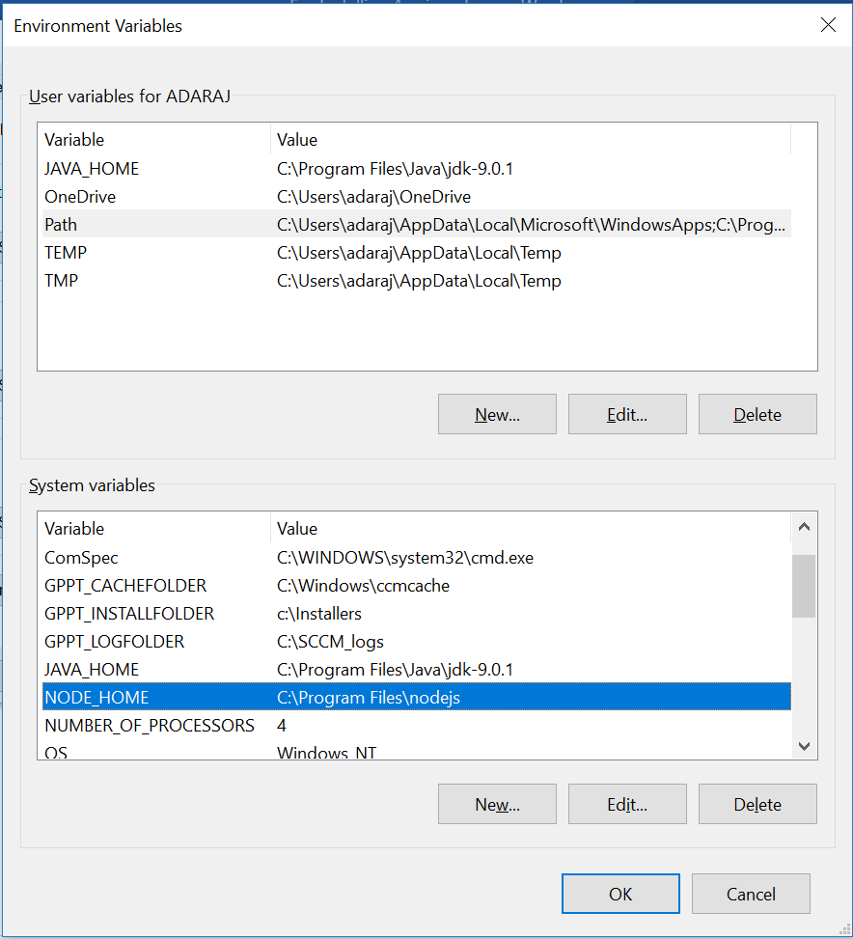

**Provide node location in path as well**

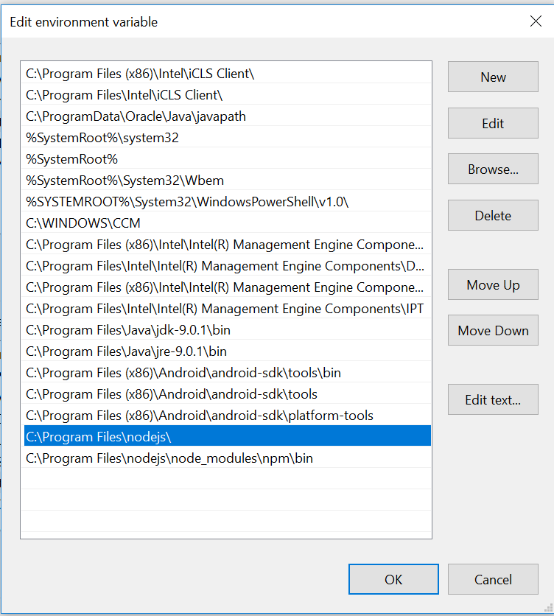

1. **Set npm environment variable in path**

**Eg:**

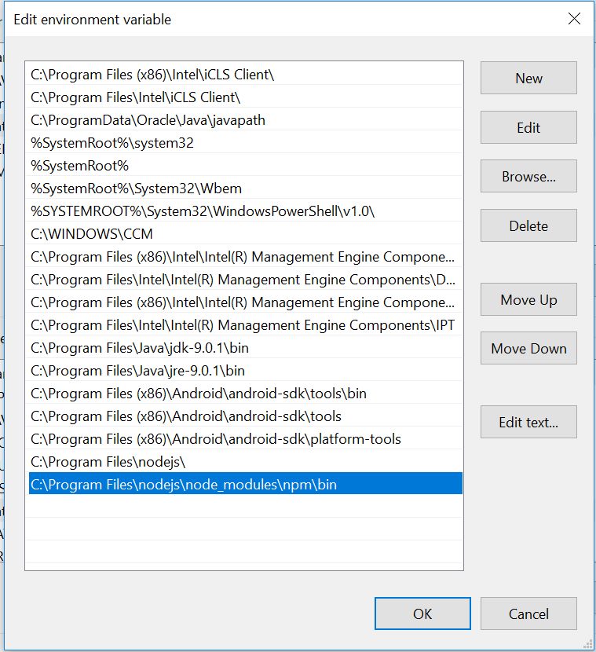

1. **For downloading Appium via npm server**

**Type 🡪 npm install -g appium in command prompt**

**Type 🡪 Appium in command prompt.**

1. **For downloading Appium for desktop 🡪** [**https://github.com/appium/appium-desktop/releases/tag/1.8.0**](https://github.com/appium/appium-desktop/releases/tag/1.8.0)
2. **Download Eclipse from 🡪** [**https://www.eclipse.org/downloads/**](https://www.eclipse.org/downloads/)